**Analysis and Visualization of Uber Data**

Uber raw data (<https://www.kaggle.com/fivethirtyeight/uber-pickups-in-new-york-city>) is used in this data visualization project. The dataset used in this project is Uber trip data from 2014 (April - September), separated by month, with detailed location information.

The files are separated by month and each has the following columns:

Date/Time: The date and time of the Uber pickup.

Lat: The latitude of the Uber pickup.

Lon: The longitude of the Uber pickup.

Base: The TLC base company code affiliated with the Uber pickup.

These files are named:

uber-raw-data-apr14.csv

uber-raw-data-aug14.csv

uber-raw-data-jul14.csv

uber-raw-data-jun14.csv

uber-raw-data-may14.csv

uber-raw-data-sep14.csv

**1.Trips by passengers in a day:** From the below picture, we can see the number of passengers’ fares throughout the day. Total 67227 passengers used uber between 1:00 to 2:00 AM. 193094 passengers used uber service for in morning around 7:00 to 8:00 AM.

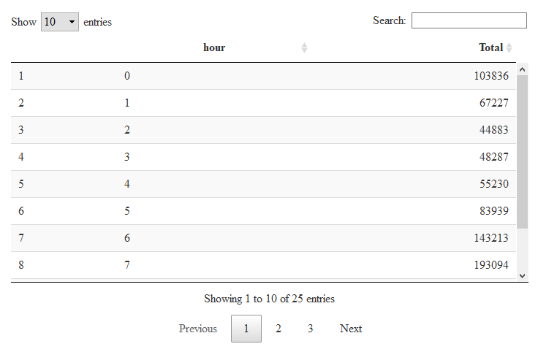

In the next image, same information is displayed in a graph form. We can observe that the number of trips are higher in the evening around 5:00 and 6:00 PM.

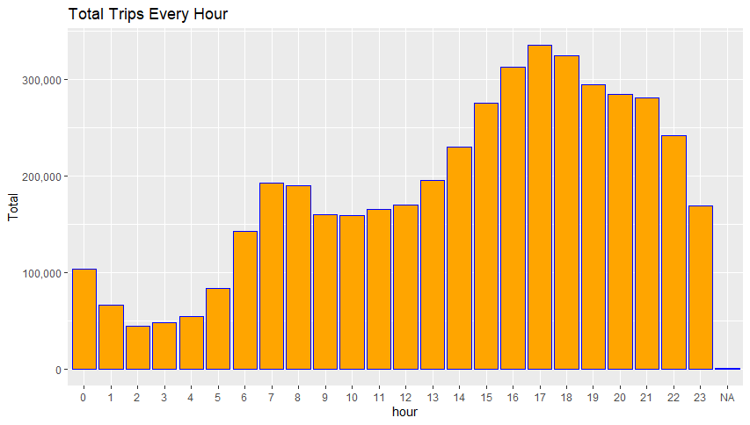

More detailed representation of trips by hours and months.

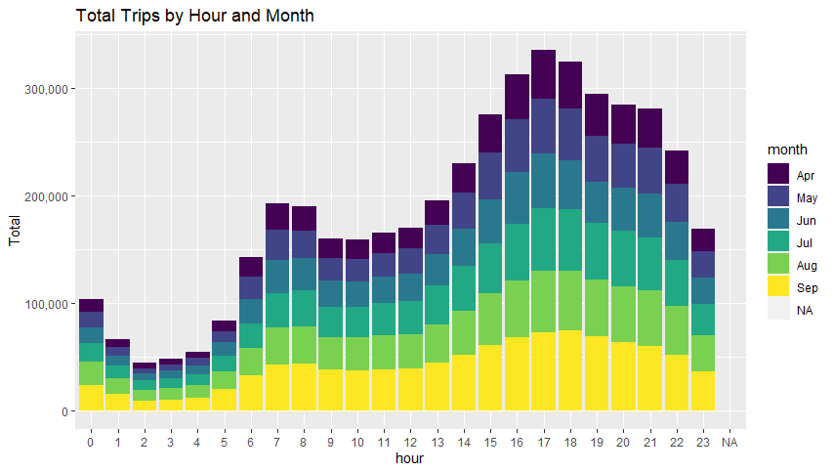

**2. Trips during every day of the month:** The following figure demonstrates total number of trips based on every day of the month. 30th of the month had the highest trips and 31th of the month had the lowest trips.

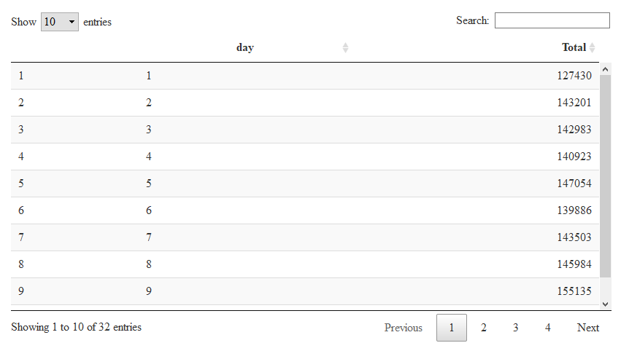

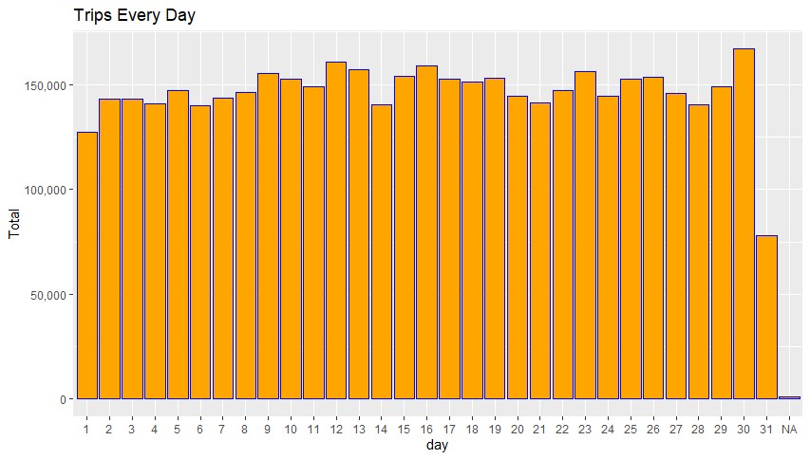

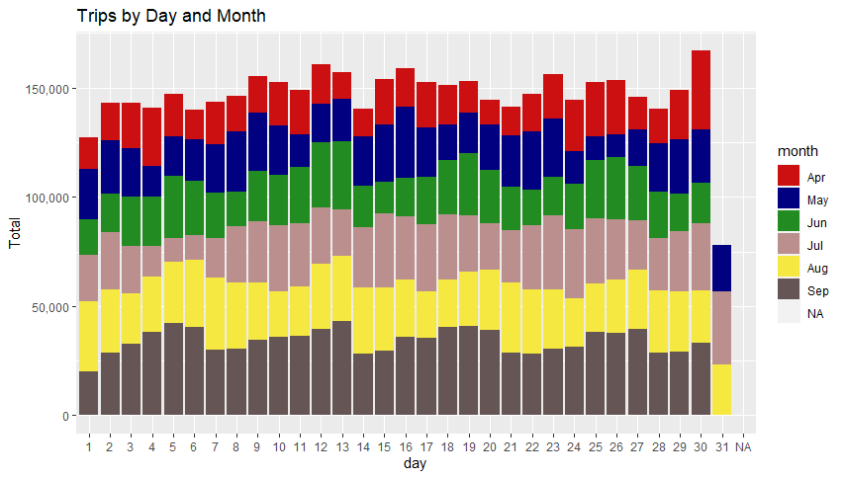

**3. Number of Trips taking place during months in a year:** The given table shows the number of trips that took place in each month.

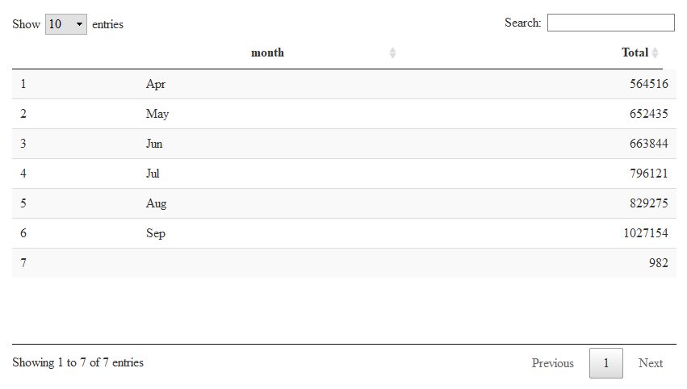

We can clearly observe from the below graph that most trips were made during the month of September and least trips were made during the month of April.

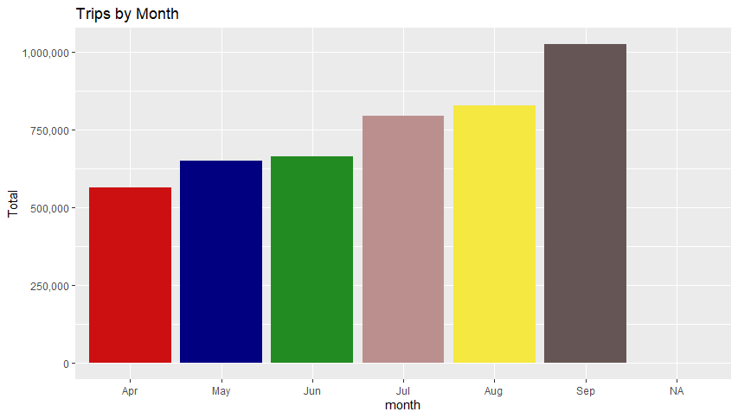

The following graph shows the number of trips that were made on every day of the week.

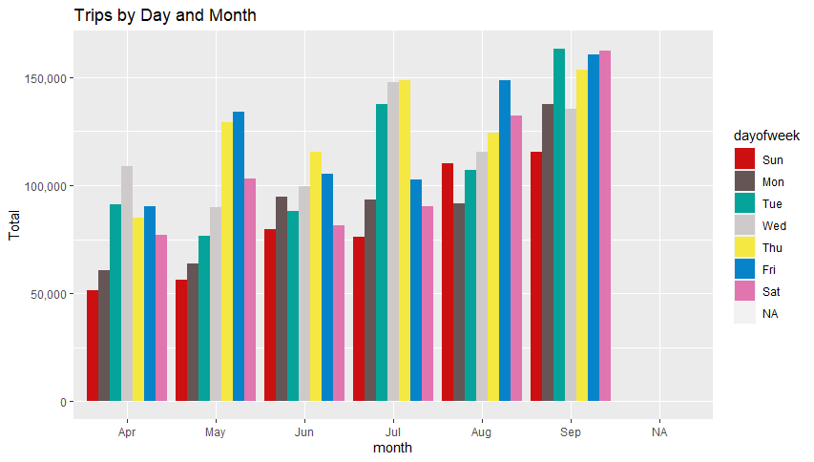

**4. Number of trips by bases:** The total number of trips made by five base stations is shown below. B02617 had the highest number of trips where B02512 had the lowest number of trips.

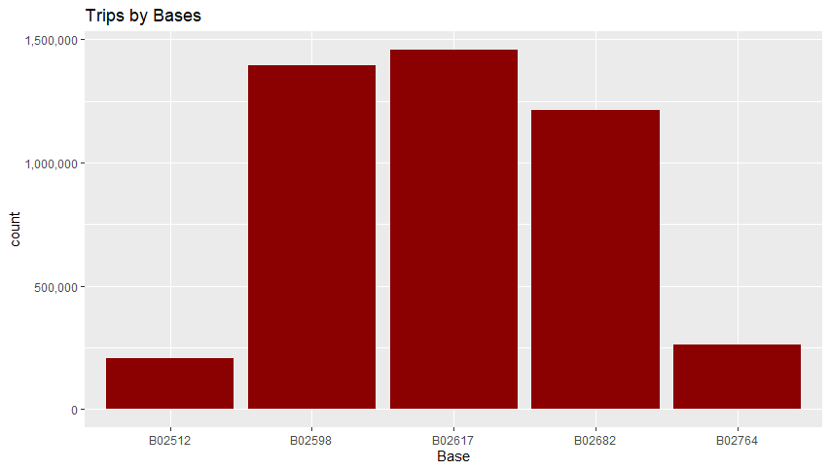

In addition, basesB02617 had highest number of trip on the month September.

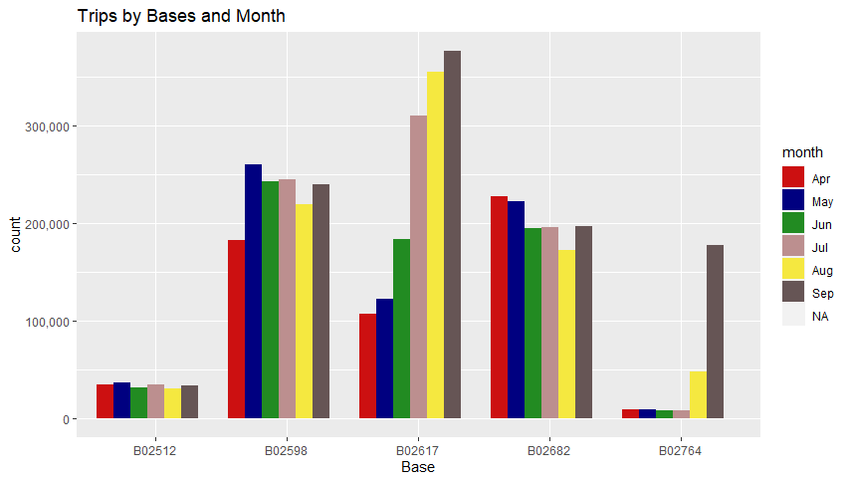

And, Thursday observed highest number of trips in majority of the bases. Sunday observed the lowest number of trips in all the five bases.

